## **Bayesian CNN**

**Model Architecture of Bayesian CNN**

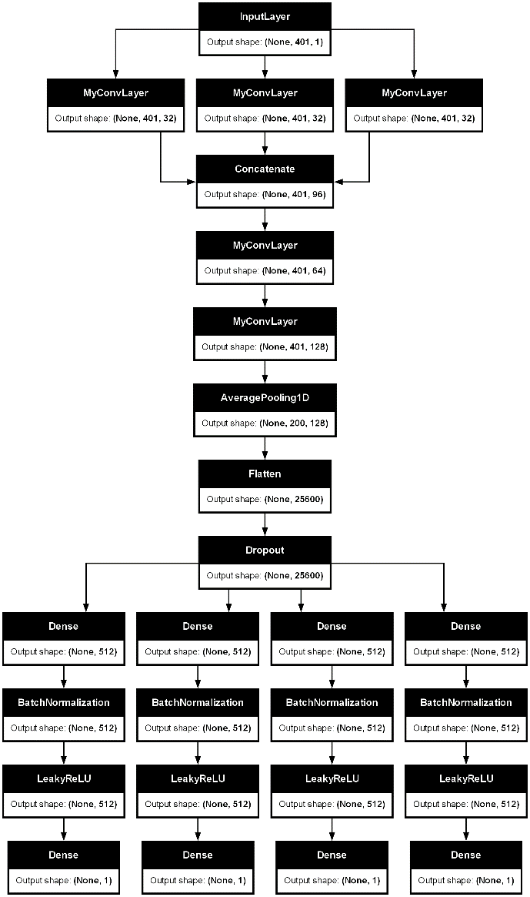

Why Bayesian CNN?

* To determine the uncertaintites, it is primiarly used for the noisy data. That’s why it has been chosen
* Bayesian approach uses `Conv1DFlipout` layers for probabilistic outputs, unlike traditional `Conv1D` layers.

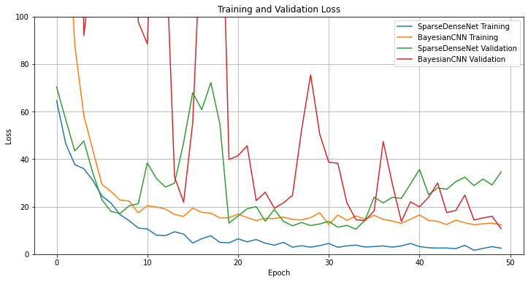

**Loss comparison of Training and Validation**

Results:  
 When compared with the training time for 50 epochs

1. Sparse Densenet – 246 s
2. BayesianCNN – 490 s

As known, there is a significant loss found from the plot

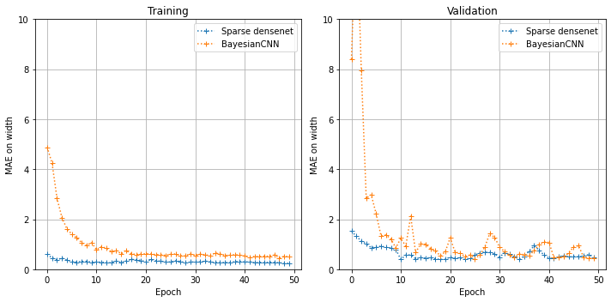 **Width**

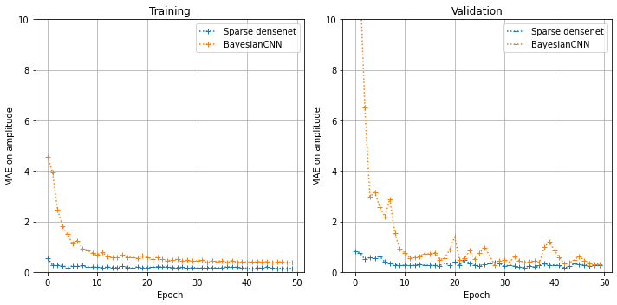**Amplitude**

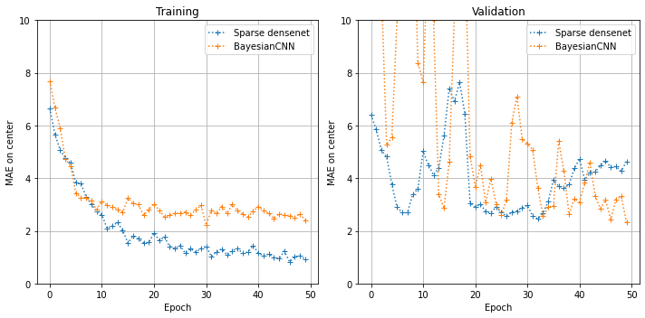**Center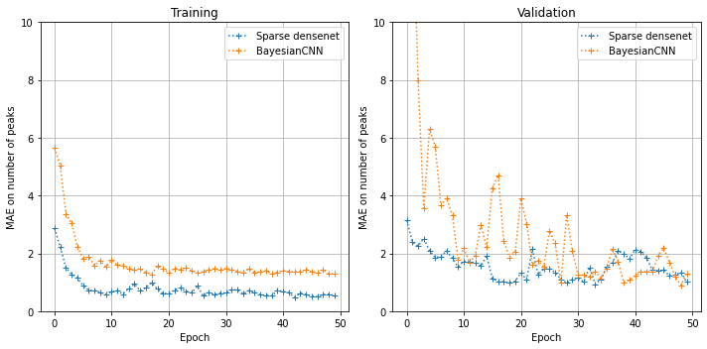Peak Number**